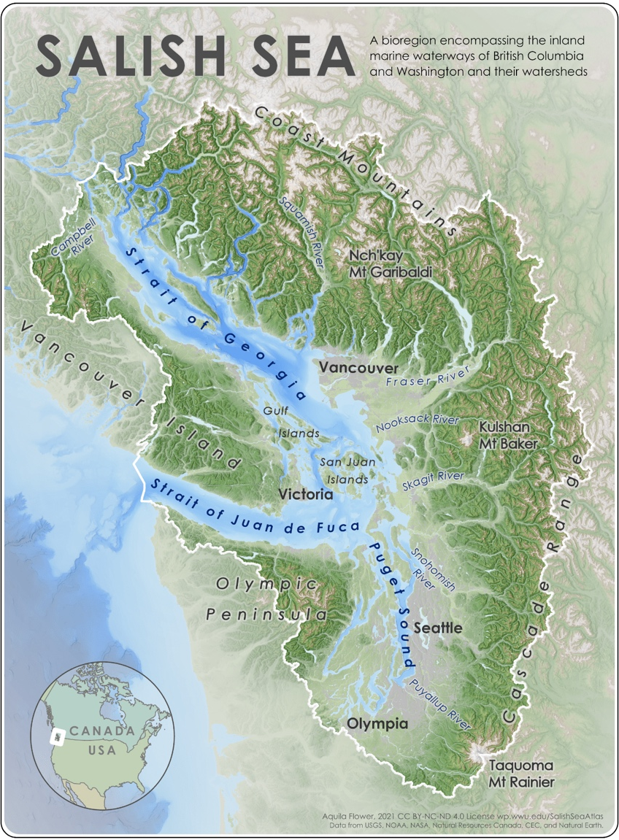
Salish Sea Studies
Activity:
Map Collection

Western Washington University

Designed by Natalie Baloy and Dennis Matthews

For more information, please contact: Natalie.Baloy@wwu.edu

Map: Aquila Flower 2021 -
Salish Sea Reference Map

About the Map Collection
The Map Collection at Western Washington University library is a multidisciplinary collection of cartographic materials, housing over 75,000 contemporary and historic maps including atlases, reference books, and globes. The collection covers many areas of the world, with a focus on the Salish Sea, the Pacific Northwest, and parts of western and northern Canada.
The Map Collection’s primary focus is to support the teaching, learning, and research needs of Western Washington University students and educators. The library promotes the use of and access to local, state, regional, and federal resources through scholarly research and public programming. The library is committed to fostering an inclusive and equitable teaching, learning, and research community across the Salish Sea region.
The Map Collection is located in Wilson Library 2 East (WL 290). If you need help with a research question or need instructional support please call the library at (360) 650-3272 or email mapcollection@wwu.edu. Visit https://library.wwu.edu/find/mapcollection for more information.

Visiting the Map Collection
Since the formation of Salish Sea Studies, all face to face classes have visited the Map Collection at Western Libraries. This visit is often held mid-quarter and provides students an opportunity to do research toward their map-based assignments and to connect spatial knowledge with other things they’re learning in the Introduction to the Salish Sea class.

About this Activity
Dr. Natalie Baloy collaborated with librarian Dennis Matthews to develop this activity. Together, they brainstormed different ways for students to experience the Salish Sea through maps in the Map Collection.

Staging this Activity
Before the class visit, Dennis sets up the different stations in the Map Collection and supplies each station with relevant maps. At the start of the activity, Dennis shares about the Map Collection and the resources students can access for their research and map-based assignments. Natalie breaks students into groups then assigns each group a starting station. Every five minutes, groups rotate to the next station until they have completed each station in written notes in the worksheets. Some of the stations involve meeting with the instructor(s), providing mid-quarter feedback, and completing course reflections.

Station Instructions for Students

Before you begin, assign group roles:

- Timekeeper: set clock for 8 minutes when you reach a new station
- Facilitator: share the prompt for discussion and make sure that each person has a turn to briefly share their response
- Cartographer: add layers and notes to your group’s Salish Sea map
- Scribe: take notes on the worksheet for the group
- Spokesperson: if your group is called on, share out what you’ve discussed or questions that are coming up

At each station, spend several minutes just looking at the maps together. Discuss the station’s question, take notes as a group on this worksheet and your group’s map. Look for your place at each station and take notes on your personal Salish Sea map in your reflection packet.

Stations

Station 1: Satellite Maps
Describe the Salish Sea from the eyes of a snow goose, who migrates to the Skagit and Fraser each winter from their mating grounds in Alaska.

Station 2: Raised Relief and Physical Geography Maps
Describe one of the Salish Sea watersheds in British Columbia and one of the watersheds in Washington from the perspective of a drop of water or snow melt

Station 3: Historic Maps
Describe the Salish Sea as a human observing the sea from the bow of a boat at different times in history - aboard a small skiff, a tall ship, a canoe, a gillnetter, etc.

Station 4: Nautical Charts
Describe the Salish Sea from the eyes of a Transient Bigg’s Orca, who travels in and out of the Salish Sea region in search of prey - or as a pilot on an oil tanker heading from Westridge Marine Terminal to the open waters of the Pacific

Station 5: Pictorial and Human / Cultural Geography Maps
Describe the Salish Sea as an urban planner, an artist, and environmental journalist, highlighting key features, land and water lessons and use, events, etc.

Station 6: Book Maps & Place Portfolio Ideas
You can work on this as a group or take time to work through these questions individually in regards to each of your assigned places.

What is special about your assigned place? What will you choose to focus your map on and why? How will you convey a story about your place through mapping? What resources do you need to tell this story?

Station 7: Meeting with Instructor Team
Ask questions about the assignment, share ideas, ask about relevant resources, look at good examples of past student maps, etc.

Station 8: Reflection Packets & Mid-Quarter Class Feedback
Prepare your reflection journal for us to collect today - make sure your name is on it, that you’ve filled in Weeks #1-5, etc. Then, se the scrap paper provided to provide feedback on the course so far: 1) KEEP: What’s going well in SALI 201? What is helping you to learn and be engaged? 2) STOP: What’s not working for you? What is hindering your learning and participation? 3) TRY: What other ideas do you have for our time together in the second half of the quarter?

