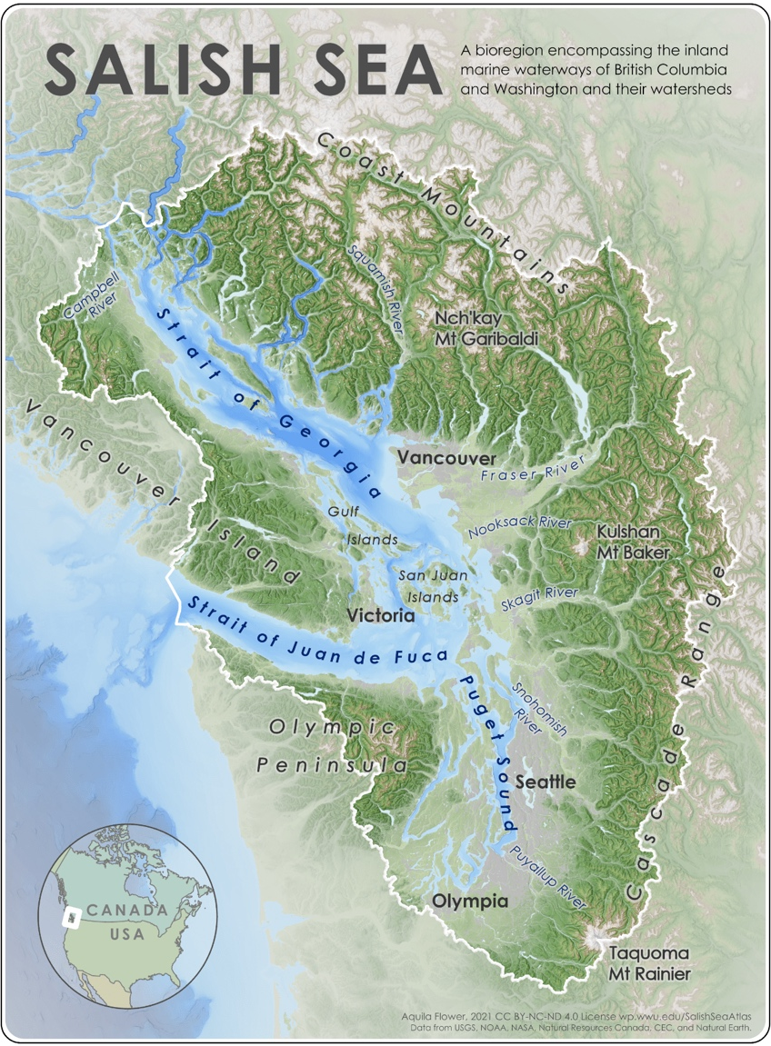
Salish Sea Studies
Activity:
Embodied Mapping

Western Washington University

Designed by Natalie Baloy

For more information, please contact: Natalie.Baloy@wwu.edu

Map: Aquila Flower 2021 -
Salish Sea Reference Map

About this Activity
I came up with this activity while trying to think of playful ways for students to test their knowledge of the geography of the Salish Sea – and to experience in an embodied way how their mental maps are shaped by the Canada-US border. The first time I taught Intro to the Salish Sea, I invited students outside mid-quarter to a grassy area overlooking the Salish Sea on Western Washington University. I gave each of them a scrap of paper with a place name on it. I pointed out markers on the landscape to demarcate the north, south, east, and west of the Salish Sea. I told students they could talk with each other, use their phones, and consult course materials to determine where to stand on our collectively-created “map.” There was a lot of discussion, a little chaos, and some laughing, and some students still tell me years later they remember it all vividly.

Staging this Activity
- Before class, print out Salish Sea places (see below)
  - Try to get a mix of different landscape features (islands, rivers, cities)
  - Try to get a mix of Canada vs. United States places (green are Canada, orange are US but don’t tell your students that)
- Find a flat place outside
- Tell your students to bring their phones and class materials with them
- Designate markers for north, south, east, and west to give a basic starting point – consider showing them the 49th parallel on the imaginary map you’re all creating
- Tell students to spend 3-5 minutes looking up their place and deciding where to position themselves on the “Map”
- Once they’ve positioned themselves, ask them to talk with the nearest 3-5 people to triangulate their location with other places, then adjust their position accordingly
- Once everyone is confident about where they are positioned, ask students to call out their place name
- Ask the group if anyone’s position needs to be adjusted
- If time permits, ask each student to share something special about their assigned place

Salish Sea Places

Valdes Island | Neah Bay | Mount Baker
Hornby Island | Puyallup | Mount Rainier
Gambier Island | Everett | Mount Garibaldi
Whidbey Island | Gibsons | Mount Tantalus
Harstine Island | Powell River | Mount Waddington
Stuart Island | Vancouver | Tsitika Peak
Anderson Island | Richmond | Victoria Peak
Fidalgo Island | Ladysmith | Mount Angeles
Camano Island | Nanaimo | Mount Constitution
Denman Island | Port Townsend | Mount Shuksan
Sucia Island | Abbotsford | Comox Lake
Quadra Island | Poulsbo | Lake Crescent
Waldron Island | Squamish | Chilliwack Lake
Vashon Island | Saanich | Lake Whatcom
Gabriola Island | Mount Vernon | Harrison Lake
Cortes Island | Redmond | Pitt Lake
Mayne Island | Blaine | Coquitlam Lake
Marrowstone Island | Sechelt | Indian Arm
Thetis Island | Kent | Sechelt Inlet
Lopez Island | Campbell River | Jervis Inlet
Prevost Island | Sequim | Lake Cushman
Salt Spring Island | Tacoma | Hood Canal
San Juan Island | Chilliwack | Totten Inlet
Galiano Island | Anacortes | Budd Inlet
Saturna Island | Friday Harbor | Lake Washington
Pender Island | Bellingham | Nooksack River
Bainbridge Island | Ganges | Baker Lake
Bowen Island | Oak Harbor | Fraser River
Orcas Island | Burnaby | Skagit River
Moresby Island | Bremerton | Nisqually River
Shaw Island | Victoria | Puyallup River
Lummi Island | Parksville | Skagit River
Penelakut Island | Federal Way | Nanaimo River
Sidney Island | Shelton | Campbell River
Texada Island | Olympia | Squamish River
Lasqueti Island | Port Angeles | Cowichan River
Yellow Island | Port Renfrew | Elwha River
Cypress Island | Duncan | Snohomish River
Vendovi Island | Surrey | Dosewallips River

