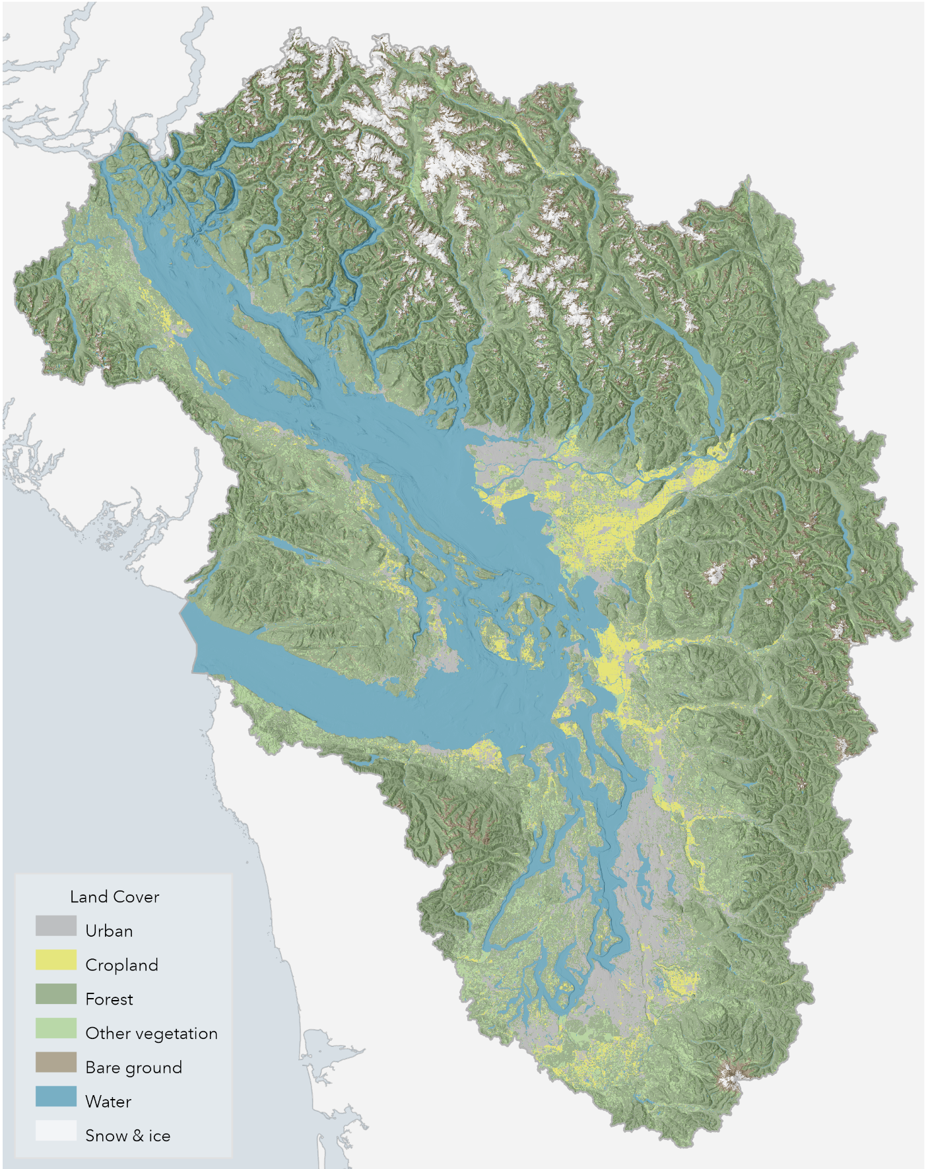
SALISH SEA MAP LIBRARY WORKSHEET

Map: Land Cover - Aquila Flower, 2020

STATION INSTRUCTIONS

Before you begin, assign group roles:

- Timekeeper: set clock for 8 minutes when you reach a new station

- Facilitator: share the prompt for discussion and make sure that each person has a turn to briefly share their response

- Cartographer: add layers and notes to your group’s Salish Sea map

- Scribe: take notes on the worksheet for the group

- Spokesperson: if your group is called on, share out what you’ve discussed or questions that are coming up

At each station, spend several minutes just looking at the maps together. Discuss the station’s question, take notes as a group on this worksheet and your group’s map. Look for your place at each station and take notes on your personal Salish Sea map in your reflection packet.

STATIONS
- Station 1: Satellite Maps
- Station 2: Raised Relief and Physical Geography Maps
- Station 3: Historic Maps
- Station 4: Nautical Charts
- Station 5: Pictorial and Human / Cultural Geography Maps

Station 6: Book Maps & Place Portfolio Ideas

Station 7: Meeting with Instructor Team

Station 8: Reflection Packets & Mid-Quarter Class Feedback

Station 1: Satellite Maps
Describe the Salish Sea from the eyes of a snow goose, who migrates to the Skagit and Fraser each winter from their mating grounds in Alaska.

Station 2: Raised Relief and Physical Geography Maps
Describe one of the Salish Sea watersheds in British Columbia and one of the watersheds in Washington from the perspective of a drop of water or snow melt

Station 3: Historic Maps
Describe the Salish Sea as a human observing human interactions with the sea from the bow of a boat at different times in history - think of being aboard a small skiff, a tall ship, a canoe, a gillnetter, etc.

Station 4: Nautical Charts
Describe the Salish Sea from the eyes of a Transient Bigg’s Orca, who travels in and out of the Salish Sea region in search of prey - or as a pilot on an oil tanker heading from Westridge Marine Terminal to the open waters of the Pacific

Station 5: Pictorial and Human / Cultural Geography Maps
Describe the Salish Sea as an urban planner, an artist, and environmental journalist, highlighting key features, land and water lessons and use, events, etc.

Station 6: Book Maps & Place Portfolio Ideas
You can work on this as a group or take time to work through these questions individually in regards to each of your assigned places.

What is special about your assigned place? What will you choose to focus your map on and why? How will you convey a story about your place through mapping? What resources do you need to tell this story?

Record your ideas in reflection packet in the Place Connections section of your Reflection Packet for this week - you’ll also have time to do this at Station #8.

Station 7: Meeting with Instructor Team
Ask questions about the assignment, share ideas, ask about relevant resources, look at good examples of past student maps, etc.

Station 8: Reflection Packets & Mid-Quarter Class Feedback
Prepare your reflection packet for us to collect today - make sure your name is on it, that you’ve filled in Weeks #1-5, etc.

Week 5 Prompts:
- Prompt 1: Share examples of the economic relationships you discussed in your ecotope group. Economic relationships include: ecosystem services, extractive industries, reciprocating kinship relations.
- Prompt 2: What is a map?
- Place Connections: What’s special about your place? What will you choose to focus your map on and why? How will you convey a story about your place through mapping? What resources do you need to tell this story? (You’ll also have time to respond more to this at Station #6.)

Mid-Quarter Feedback
Share your feedback on the class so far. Use the scrap paper provided to respond to these prompts:
- KEEP What is going well in SALI 201? What is helping you to learn and be engaged?
- STOP What is not working for you? What is hindering your learning and participation?
- TRY What other ideas do you have for our time together in the second half of the quarter?

